**LAB REPORT #4** Name: Owais Rao

**Experiment No.4** Roll No.:22L-7638

Class: BSEE-1A2

**Introduction:-**

A control structure is an instruction, statement or group of statements which determines the sequence of execution of other statements. The basic operation of if else statement is that**a statement or group of statements is executed under if, if the value of expression is true and if the expression is false, statements under else are evaluated**. C++ provides control structures that serve to specify what has to be done by our program, when and under which circumstances.

**Objective:-**

* To be able to evaluate relational expressions.
* To know the precedence rules of logical operators.

**Procedure:-**

With the help of lab manual, I was able to write codes for given exercises. They are as follows with their outputs:-

**Exercise 1:-**

#include <iostream>

using namespace std;

void main()

{

int x, y, z;

cout << "\nEnter Numbers :-\n";

cin >> x;

cin >> y;

cin >> z;

if (x > y && x > z)

cout << "\nLargest number is " << x << endl;

if (y > x && y > z)

cout << "\nLargest number is " << y << endl;

if (z > x && z > y)

cout << "\nLargest number is " << z << endl;

if (x < y && x < z)

cout << "\nSmallest number is " << x << endl;

if (y < x && y < z)

cout << "\nSmallest number is " << y << endl;

if (z < x && z < y)

cout << "\nSmallest number is " << z << endl << endl;

}

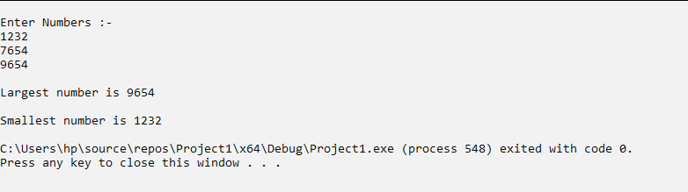

**Exercise 2:-**

#include <iostream>

using namespace std;

void main()

{

float a, b, c;

cout << "\nEnter lengths of Triangle:-\n";

cin >> a >> b >> c;

if ((a * a == b * b + c * c) || (b * b == a * a + c * c) || (c * c == a * a + b * b))

cout << "\nThe triangle is a Right Triangle" << endl << endl;

else

cout << "\nThe triangle is NOT a right triangle" << endl;

}

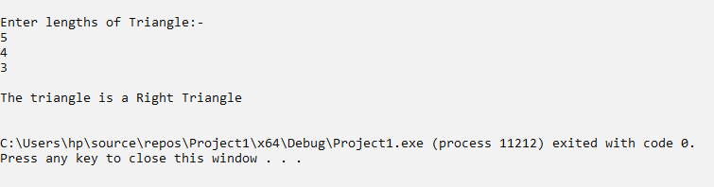

**Exercise 3:-**

#include <iostream>

using namespace std;

void main()

{

int marks;

cout << "\nEnter Marks: ";

cin >> marks;

if (marks >= 90)

cout << "\nGrade A" << endl << endl;

else if (marks >= 75)

cout << "\nGrade B" << endl << endl;

else if (marks >= 60)

cout << "\nGrade C" << endl << endl;

else if (marks >= 45)

cout << "\nGrade D" << endl << endl;

else

cout << "\nGrade F" << endl << endl;

}

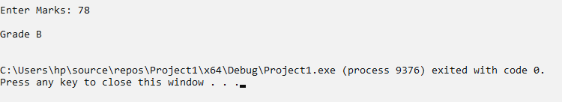

**Issues:-**

No issues were faced during programming.

**Conclusion:-**

* I was able to evaluate relational expressions.
* I became aware of the precedence order (rules) of logical operators.

**Applications:-**

* The if-else-else-if control structure is typically used to check multiple conditions.
* We use the if-else statement to run a block of code among more than one alternatives.

**Post Lab:-**

A)

#include <iostream>

using namespace std;

void main()

{

int a = 0, b = 0, c = 0;

cout << "\nEnter coefficient of x^2:";

cin >> a;

cout << "\nEnter coefficient of x:";

cin >> b;

cout << "\nEnter constant term:";

cin >> c;

if ((b ^ 2) - (4 * a * c) == 0)

cout << "\nSingle Repeated Roots" << endl;

if ((b ^ 2) - (4 * a * c) > 0)

cout << "\nTwo Real Roots" << endl;

if ((b ^ 2) - (4 * a * c) < 0)

cout << "\nTwo Complex Roots" << endl;

} 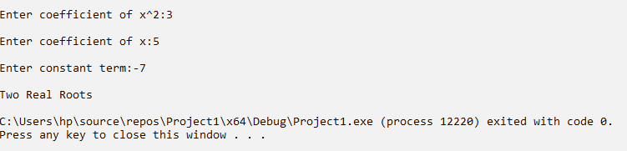

B)

#include<iostream>

using namespace std;

void main()

{

int calls, bill;

float bill2, bill3, bill4;

cout << "\nEnter the Number of Calls: ";

cin >> calls;

bill = 200;

bill2 = 200 + (0.60 * calls);

bill3 = 200 + (0.60 * calls) + (0.50 * calls);

bill4 = 200 + (0.60 * calls) + (0.50 * calls) + (0.40 * calls);

if (calls <= 100)

{

cout << "\nYour Total Bill is Rs." << bill << endl;

}

else if (calls > 100 && calls <= 150)

{

cout << "\nYour Total Bill is " << bill2 << endl;

}

else if (calls > 150 && calls <= 200)

{

cout << "\nYour Total Bill is " << bill3 << endl;

}

else

{

cout << "\nYour Total Bill is " << bill4 << endl;

}

} 